**Installing and Using Python**

To develop Python programs you can use:

1. IDE (Integrated Development Environment) – like PyCharm or Eclipse
2. IDLE (Integrated Development and Learning Environment) – an IDE that is included with the Python distributions for Windows and Linux.
3. Text Editor

First install the latest version of Python, from <https://www.python.org/downloads/>. At the time of this writing the latest version is 3.8.1. You will be using Python’s IDLE very little, just to get an idea of how to use it.

Throughout the course you are going to be using PyCharm IDE, and therefore through this lecture you will learn how to Install and use PyCharm.

[PyCharm Educational Edition](https://www.jetbrains.com/pycharm-edu/)  is a free editor which you can use for writing Python programs.

Download and install the latest version from *https://www.jetbrains.com/pycharm-edu/*

From jetbrains.com/education click on Download and then click on Python.  
The new window will display the Pycharm logo and the latest version. At the time this document was written the latest version was 2019.3. Click on Download and follow the instructions to download PyCharm. On the Installation Options select:

1. 64-bit launcher shortcut,
2. Latest Python version (3.8 or later), and
3. create associations .py

The whole process should not take more than 10 minutes.  
Run Pycharm and select:

1. Do not import settings
2. Accept the Privacy Policy
3. Data Sharing – Don’t send
4. Are you a learner or Educator – learner
5. Start using Edu Tools

PyCharm provides you with a better environment to write and run your programs using Python.

The Python Console of PyCharm provides you also the choice to run commands or even programs using command line.

After you download and install PyCharm, it would be a good idea to create a shortcut on your desktop.

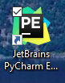

The next steps will show you the basics of how to use Pycharm to code and run Python programs.

The first part shows you how to use PyCharm’s IDE and the second the use the Console

**Part A- Using PyCharm IDE**

**Step 1 – Create a Project**

The first thing you need to do, after you install PyCharm, is to create a Project so you can store all your programs. To do so, run PyCharm and in the Welcome screen click on Create New   
Project.

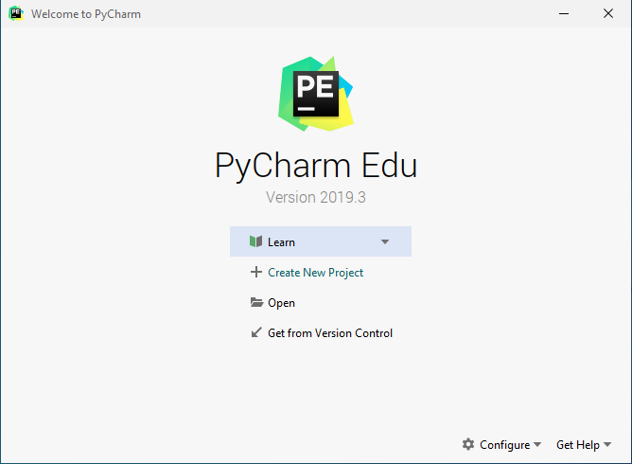

You will then be presented with the New Project window. In the Location: text bar, type **H:\Python** and click **Create**. PyCharm will create a Virtual Environment.

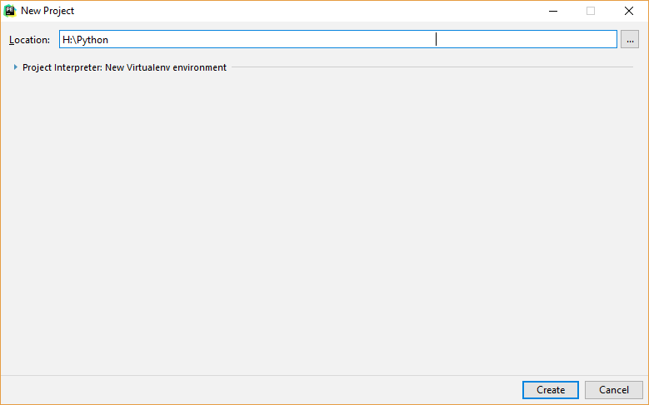

With this step you created a project named Python on the H: drive of Centennial College, and this where you will be saving all your Python files. If you wish, you may select a different drive.

**Step 2 – Name your file**

You can now start naming and writing the code of you program/file. You can do this in two ways.  
1. Right-click on the Python project you created and select **New** and from there **Python** **File.**

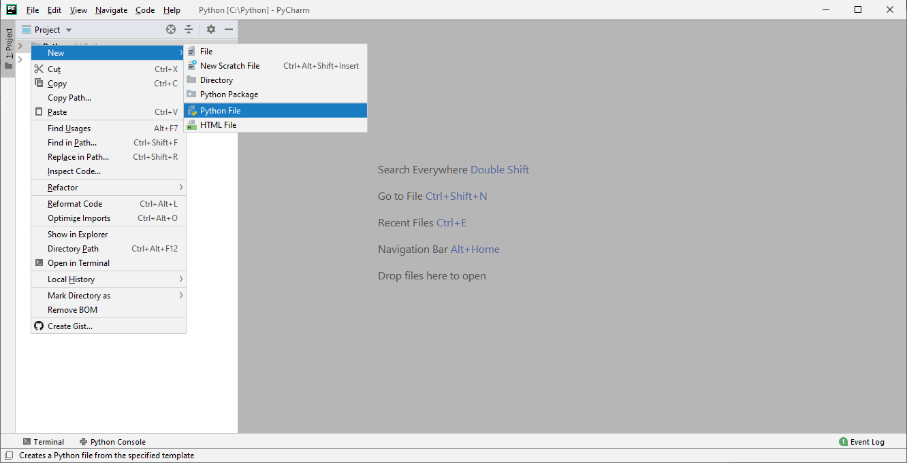

2. In the menu bar, select **File – New… – Python file**.   
No matter which method you used, you will be presented with the **New Python file** window where you can name your file.

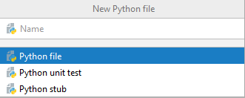

You are going to store all your Python files in the project named Python. So, try to give meaningful names based on the function of the program.   
For example the first program you will write, will output the word *Hello*, thus would be meaningful to name the file “**Hello**”.

To give a name to your program, in the *Name textbox* of the New Python file window, type the name and hit the <***Enter****> key*.

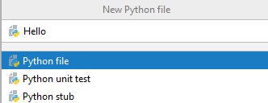

**Step 3 – Type the code**

You will now be presented with the PyCharm editor window (top-right pane), where you can start typing your code.

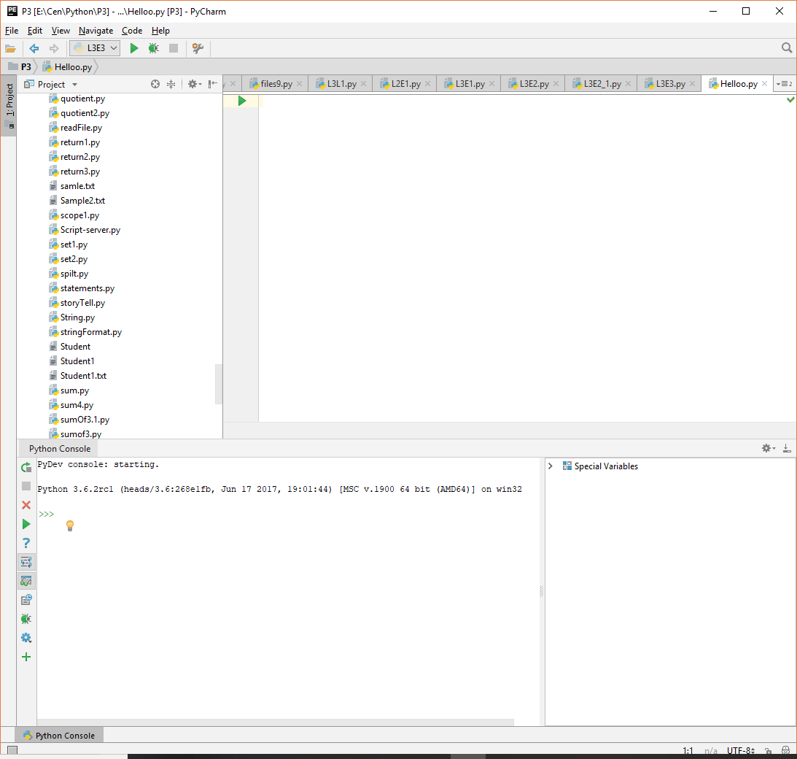\

In the editor pane type the statement

**print(‘Hello!’)**

**Step 4 – Running the File**

The file named “Hello” has just one statement: print(‘Hello’).   
To run this program, click any of the green arrows , or right-click in the editor window and select **Run ‘Hello’.** The run button may not work if it is the first time you run the file. In such a case right-click anywhere on the editor’s pane and select **Run ‘Hello’**.

The program will run and the output will display in the output pane, which is the lower pane.

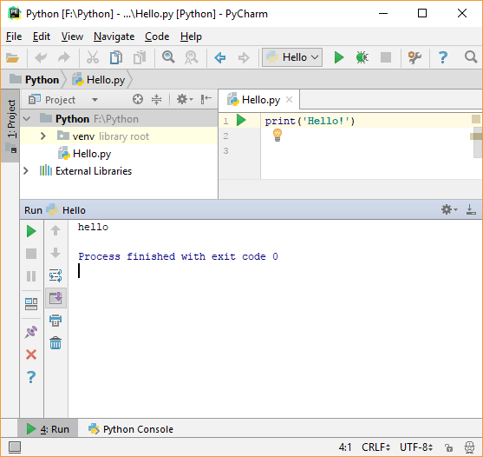

After you run your file, the program is saved in the project you created with the name **Hello.py**

**Part B – Using PyCharm’s Console**

You can use PyCharm’s console to run a single command or even a group of commands.

**Step 1 – Enter Python’s Console**

To enter the console mode (interactive), at the bottom bar, click on **Python Console**, and your PyCharm window will now look similar to the one below, where the console editor is active at the bottom left side.

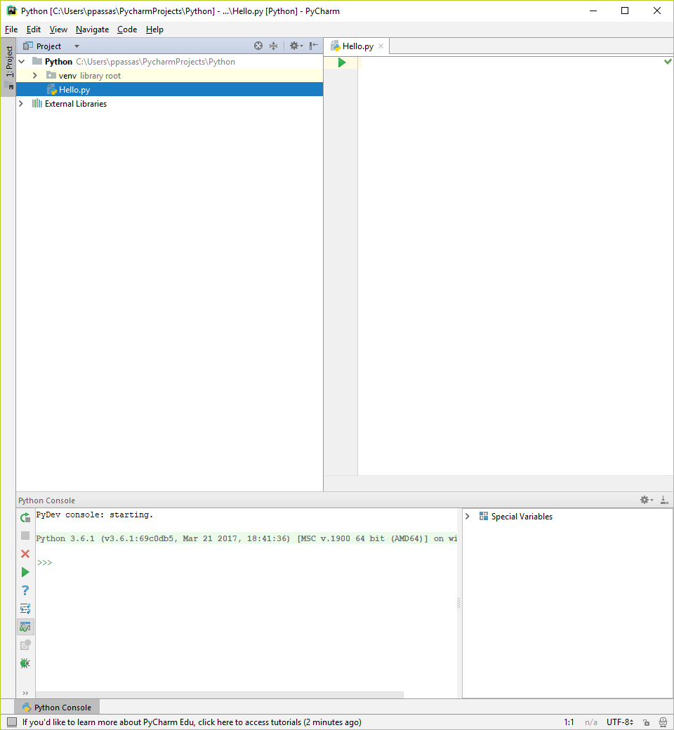

The triple arrows **>>>** is the Python’s console prompt, and is the indication that Python Console is running.   
  
You can now start typing your commands (statements) at the Python Console prompt.

**Step 2 – Enter statement**

At the prompt (>>>) type **print(‘Hello!’)** and then hit the ***<enter>*** key.   
The statement would execute and would display the output on the next line.

It would then display the **>>>** prompt again so you can enter the next command. The left-bottom corner of your window should look like the following figure.

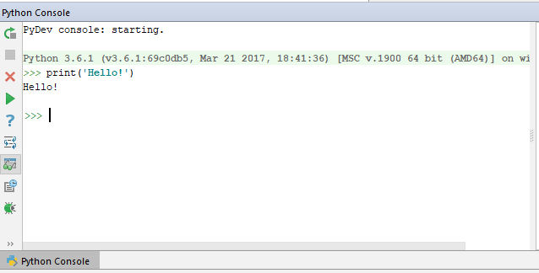

**Running a Program in the Interactive mode**

If you need to run a program in the interactive mode:

1. At the >>> type the first statement
2. Press <Shift><Enter> and the prompt will become three dots (**…**)
3. At the new prompt … type your new statement
4. Keep adding the statements and when you are done hit <**Enter**>
5. The statements will run as a program.

Example:

>>> print('What is your name', end=' ') <shift><enter>

… name = input() <shift><enter>

… print('Hi', name+’!’) <Enter>

What is your name>? Petros

Hi Petros!

**Clear the Console Screen**

To clear the console screen click on the  icon

**Quit Command Line Interpreter**

To exit Python Command line Interpreter, type **quit**

>>>**quit()**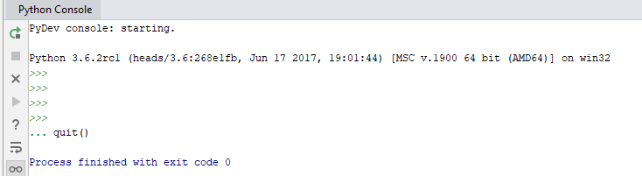

**Find Errors**

To find any errors in your code using Pycharm, in the menu bar select   
 **Code | Inspect code…**

And then select the file to be inspected

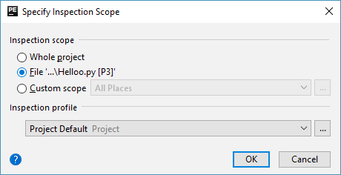

For more information about the PyCharm 2019 settings visit:

<https://www.jetbrains.com/help/pycharm/installation-guide.html>

**Running a File from Windows Command Prompt**

After you created a Python file, you can run the program using Windows.

Assuming you saved your file in H:\Python, to run the file “Hello.py” follow the next steps:

1. In the search box of Windows 10, type **cmd** to open a DOS window.
2. At the command prompt, change the current directory to the directory that contains your Python files. If you followed the previous instructions it should be *H:\Python*.
3. First change drive, by typing the drive letter followed by a colon (:), **H:,** and hit the *<enter>* key. The prompt now should be **H:\>**
4. After the > symbol type: **cd** **Python**
5. Your prompt now should be **H:\Python>**
6. Type the filename with the extension .py to run the file and hit the <enter> key.  
   H:\Python> **hello.py** <Enter>

In the following screen-shot F: drive was used instead of H:

